|  |  |  |
| --- | --- | --- |
| **2018/4/16** | **2693** | **双成药业** |

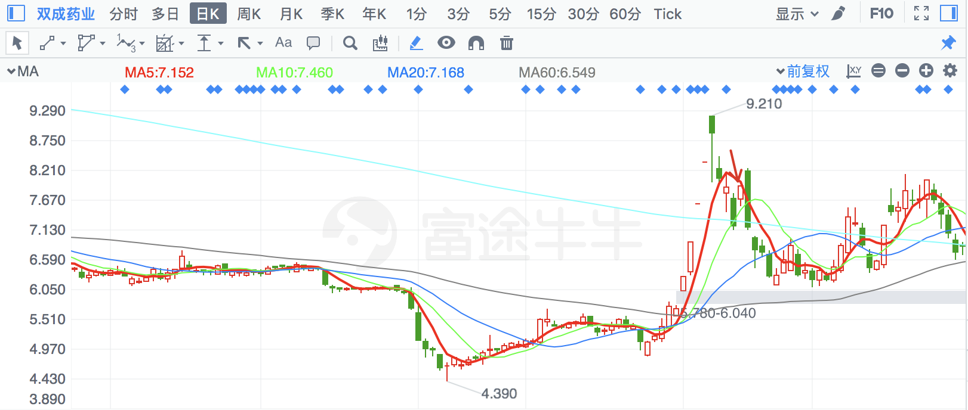

|  |  |  |
| --- | --- | --- |
| **2018/2/5** | **300140** | **中环装备** |

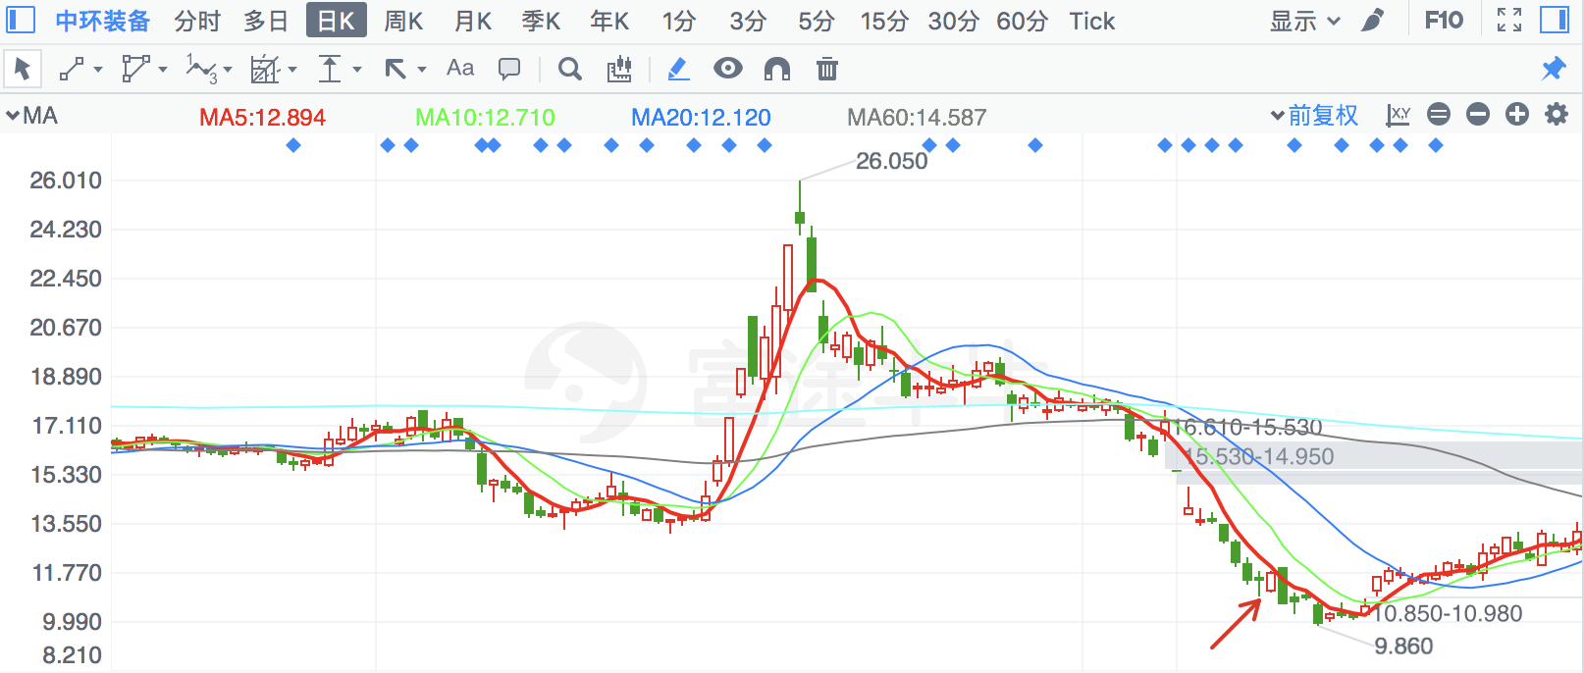

|  |  |  |
| --- | --- | --- |
| **2018/6/20** | **603089** | **正裕工业** |

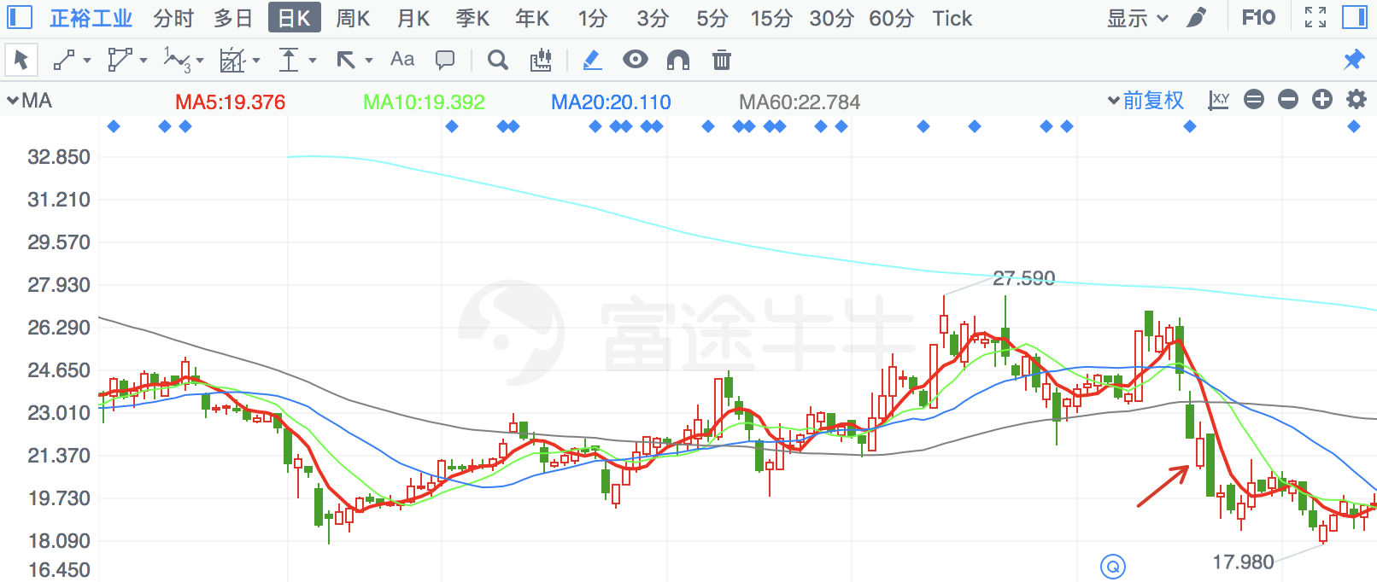

|  |  |  |
| --- | --- | --- |
| **2018/2/1** | **603016** | **新宏泰** |

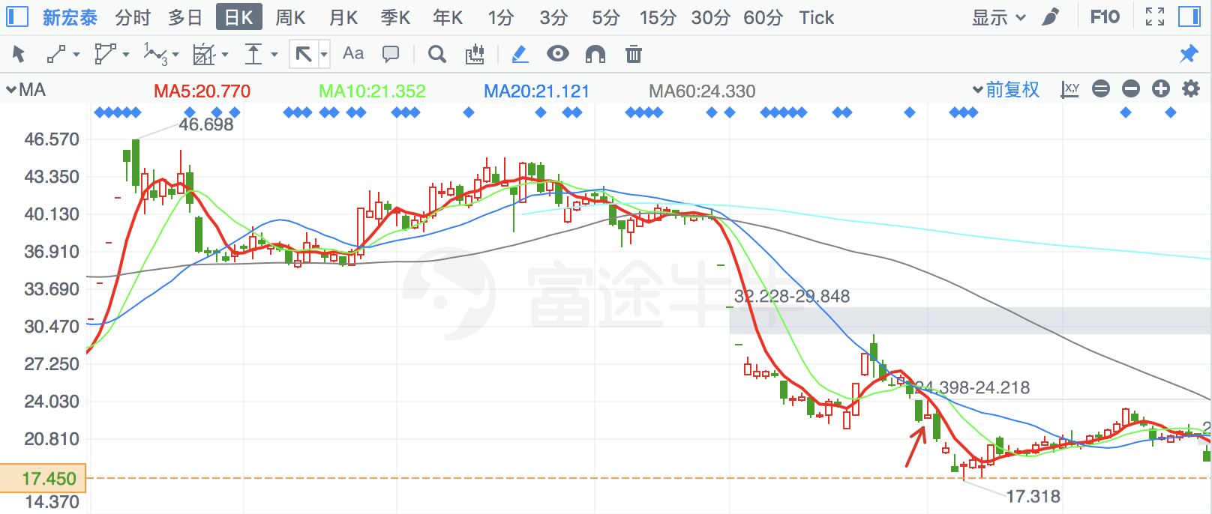

|  |  |  |
| --- | --- | --- |
| **2018/6/20** | **603500** | **祥和实业** |

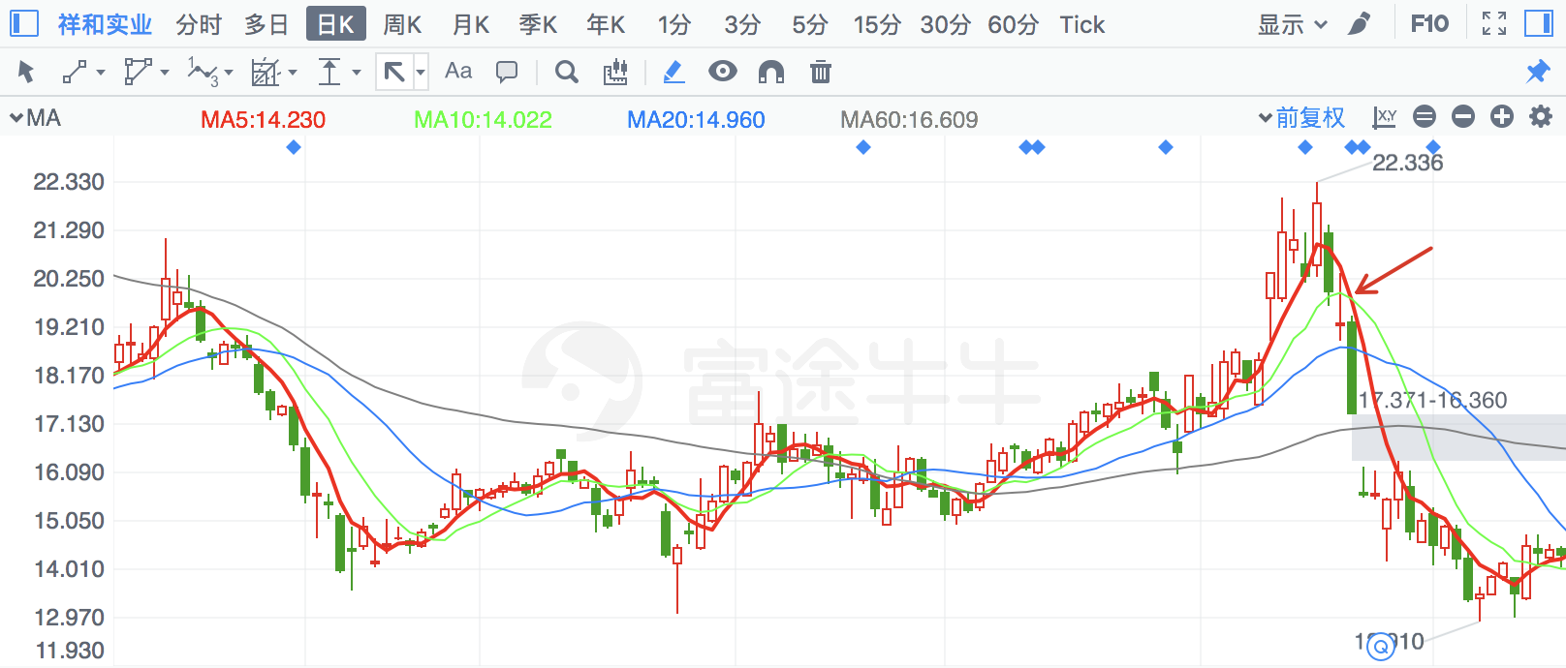

|  |  |  |
| --- | --- | --- |
| **2018/6/20** | **2645** | **华宏科技** |

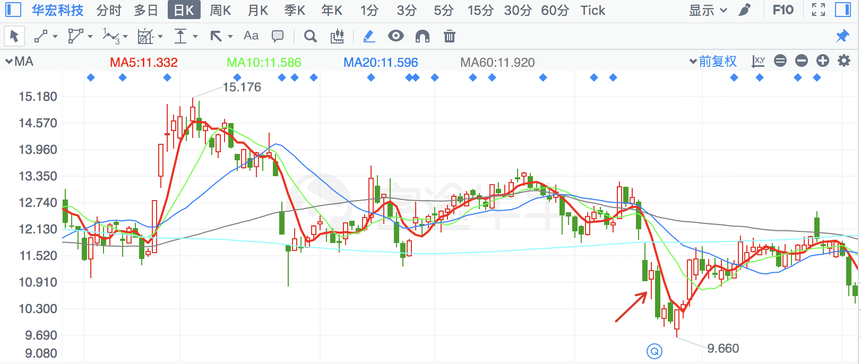

|  |  |  |
| --- | --- | --- |
| **2018/6/26** | **2672** | **东江环保** |

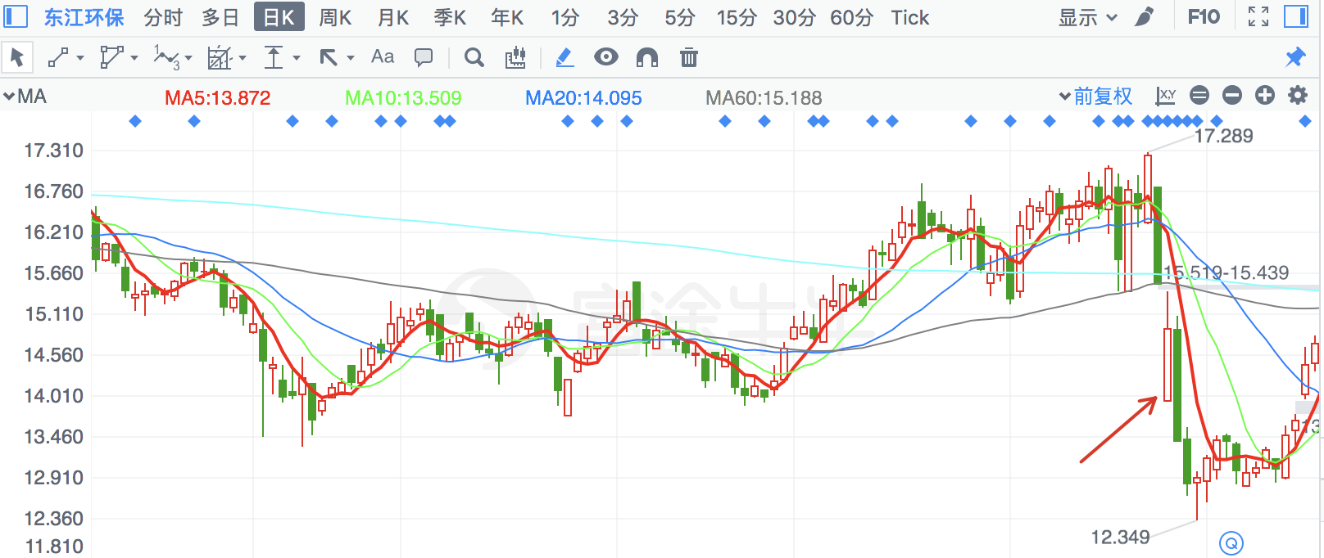

|  |  |  |
| --- | --- | --- |
| **2018/6/20** | **2730** | **电光科技** |

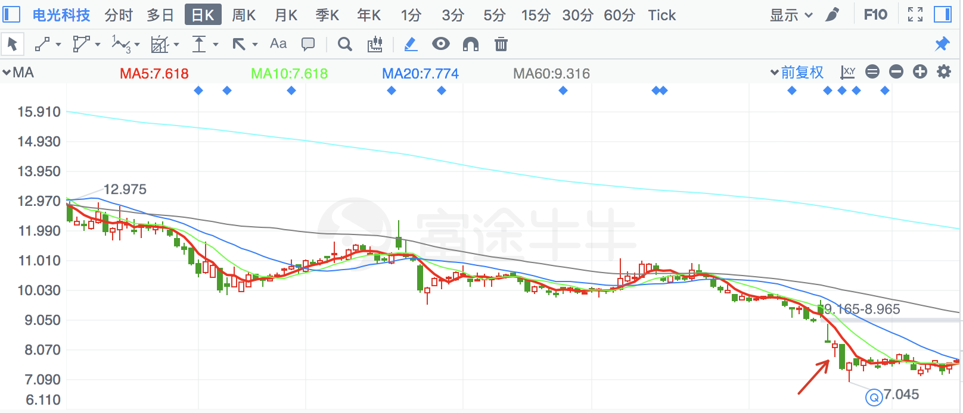

|  |  |  |
| --- | --- | --- |
| **2018/6/20** | **603559** | **中通国脉** |

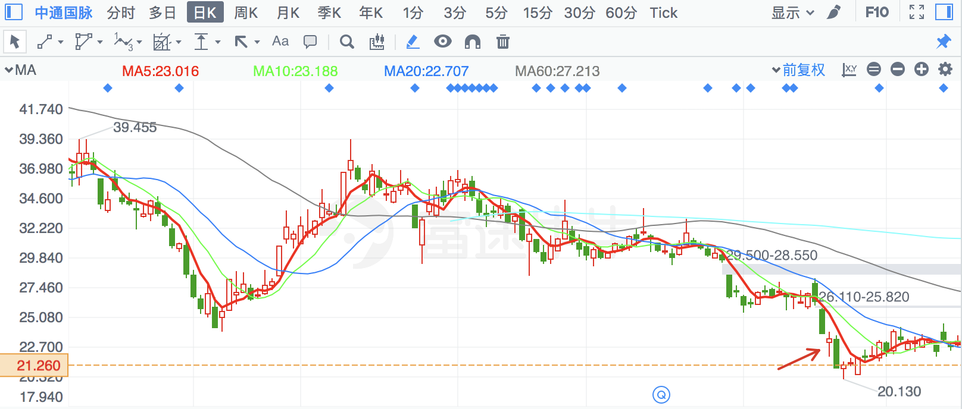

|  |  |  |
| --- | --- | --- |
| **2018/6/20** | **300629** | **新劲刚** |

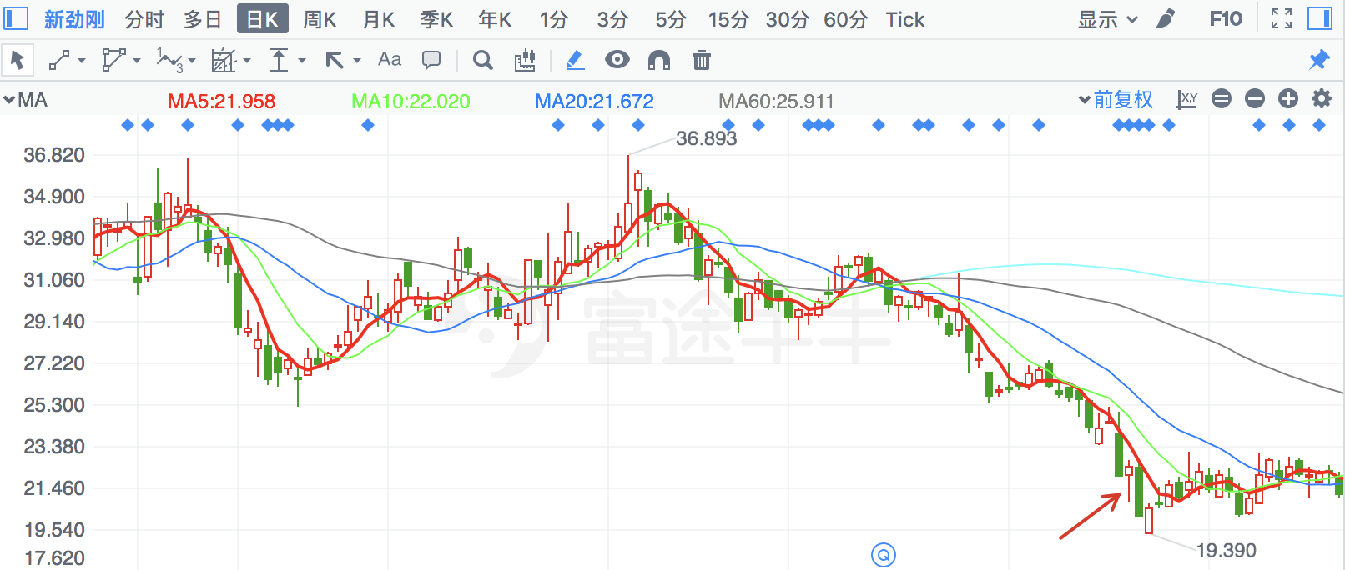

|  |  |  |
| --- | --- | --- |
| **2018/6/20** | **2618** | **丹邦科技** |

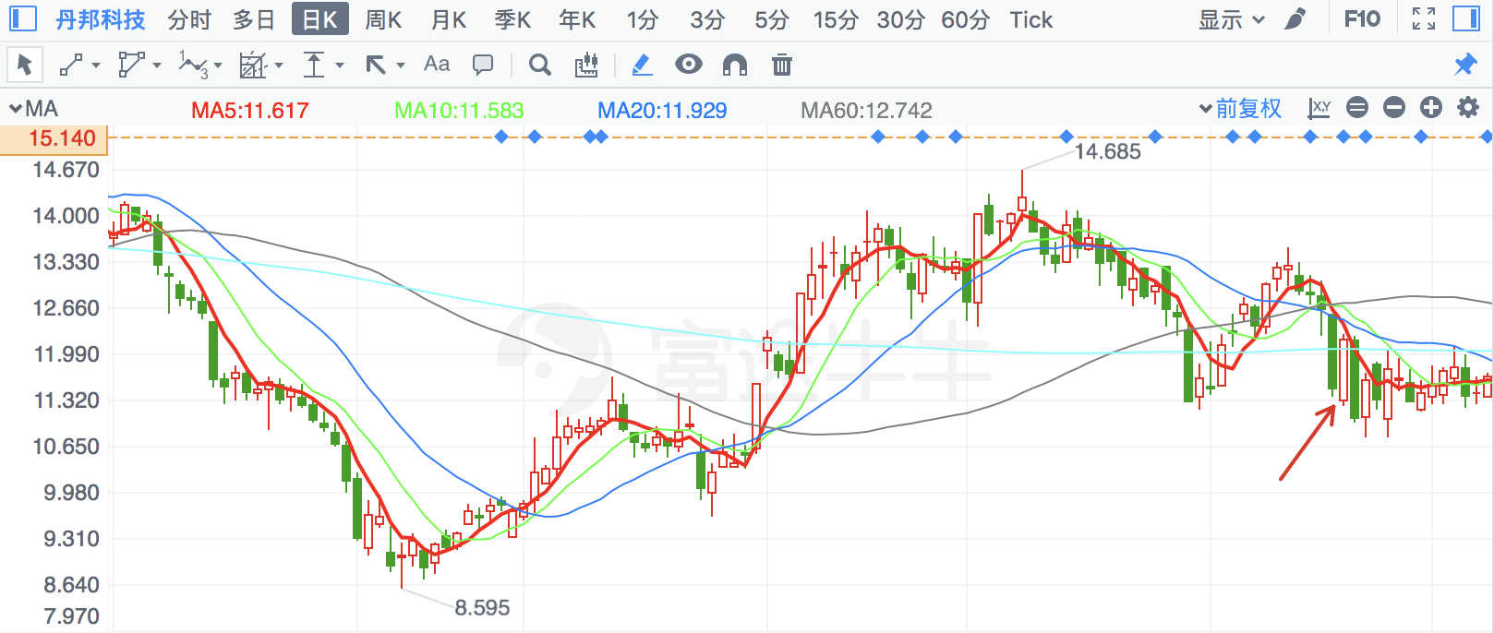

|  |  |  |
| --- | --- | --- |
| **2018/2/2** | **600197** | **伊力特** |

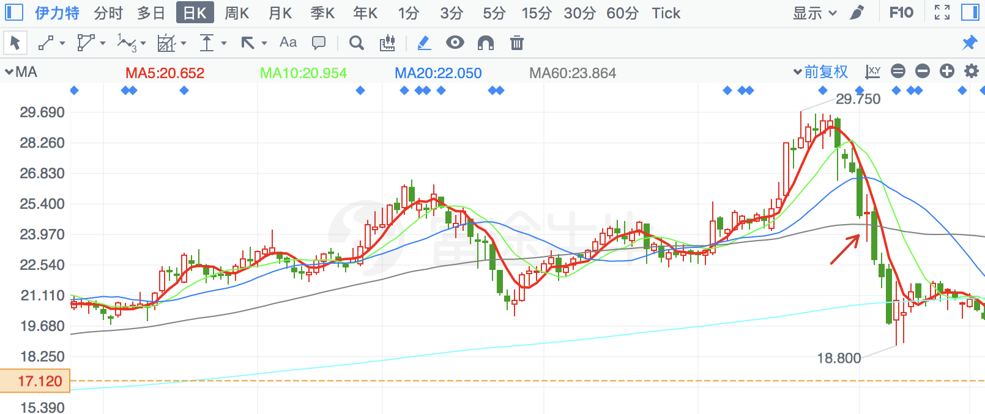

|  |  |  |
| --- | --- | --- |
| **2018/1/31** | **995** | **\*ST皇台** |

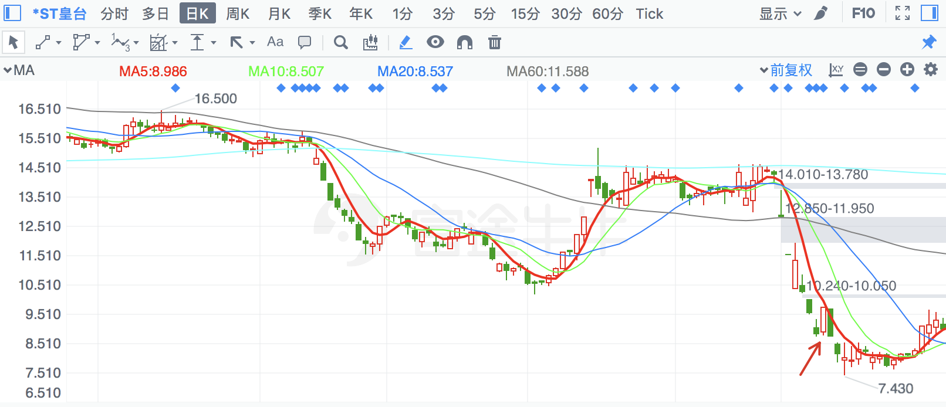

|  |  |  |
| --- | --- | --- |
| **2018/6/20** | **603322** | **超讯通信** |

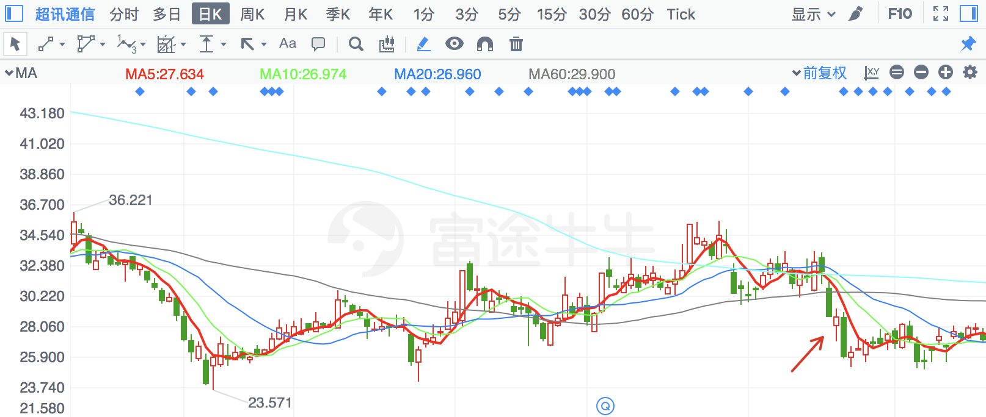

|  |  |  |
| --- | --- | --- |
| **2018/2/5** | **600749** | **\*ST藏旅** |

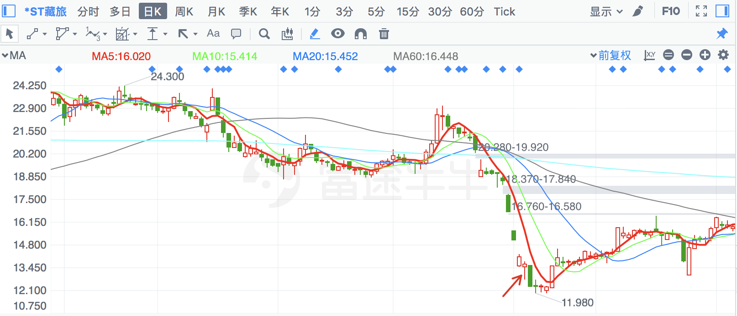

|  |  |  |
| --- | --- | --- |
| **2018/6/1** | **8** | **神州高铁** |

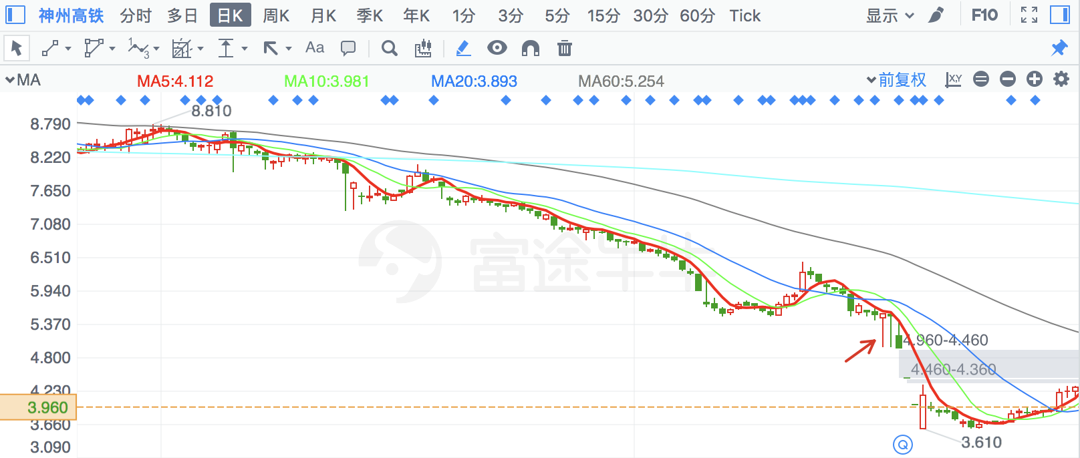

|  |  |  |
| --- | --- | --- |
| **2018/4/18** | **300226** | **上海钢联** |

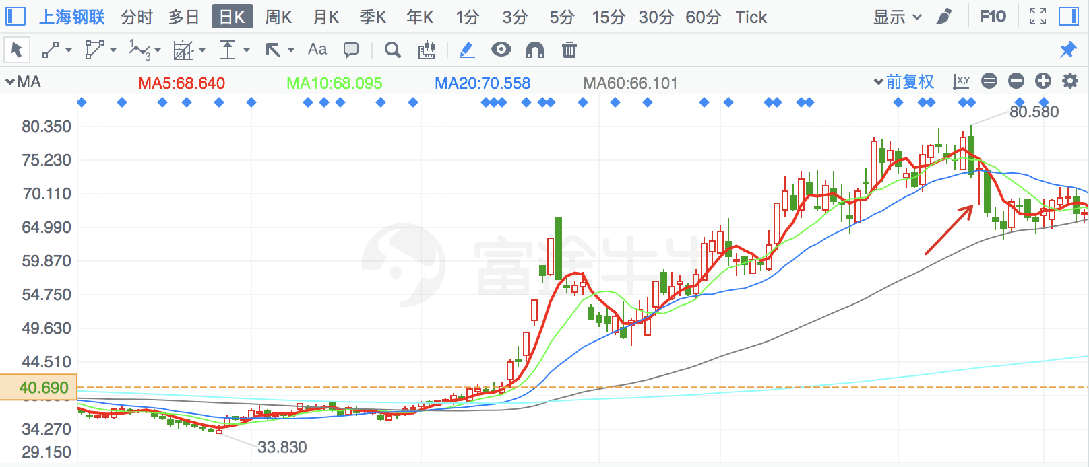

|  |  |  |
| --- | --- | --- |
| **2018/8/7** | **300238** | **冠昊生物** |

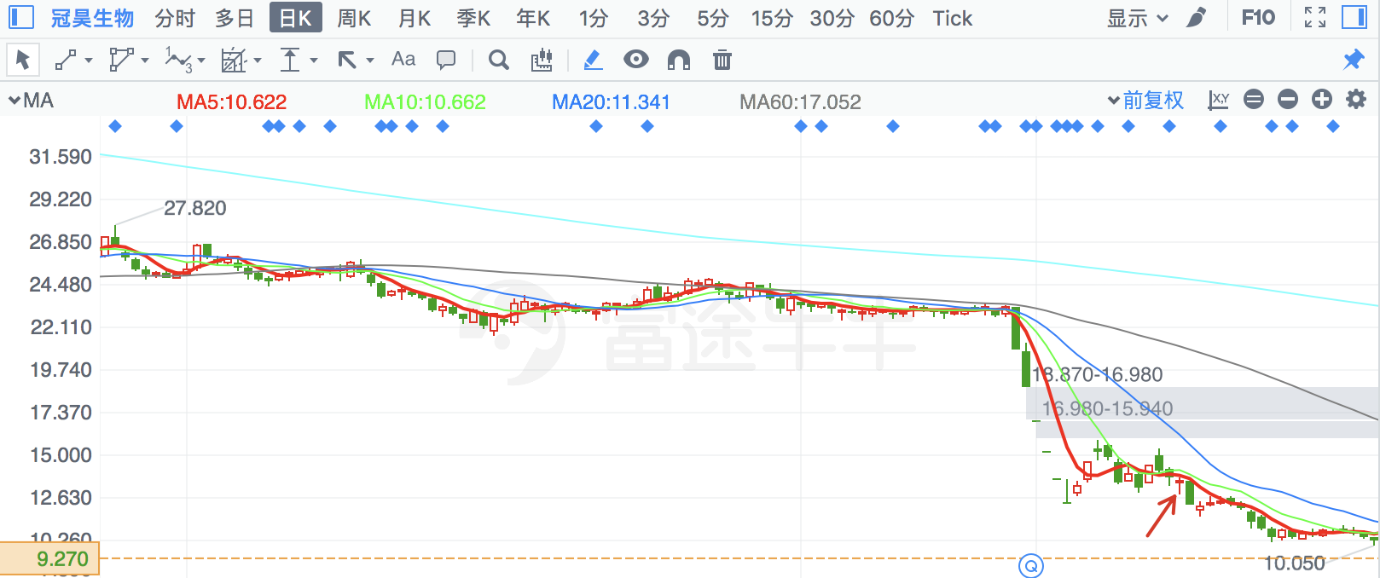

|  |  |  |
| --- | --- | --- |
| **2018/6/25** | **300023** | **宝德股份** |

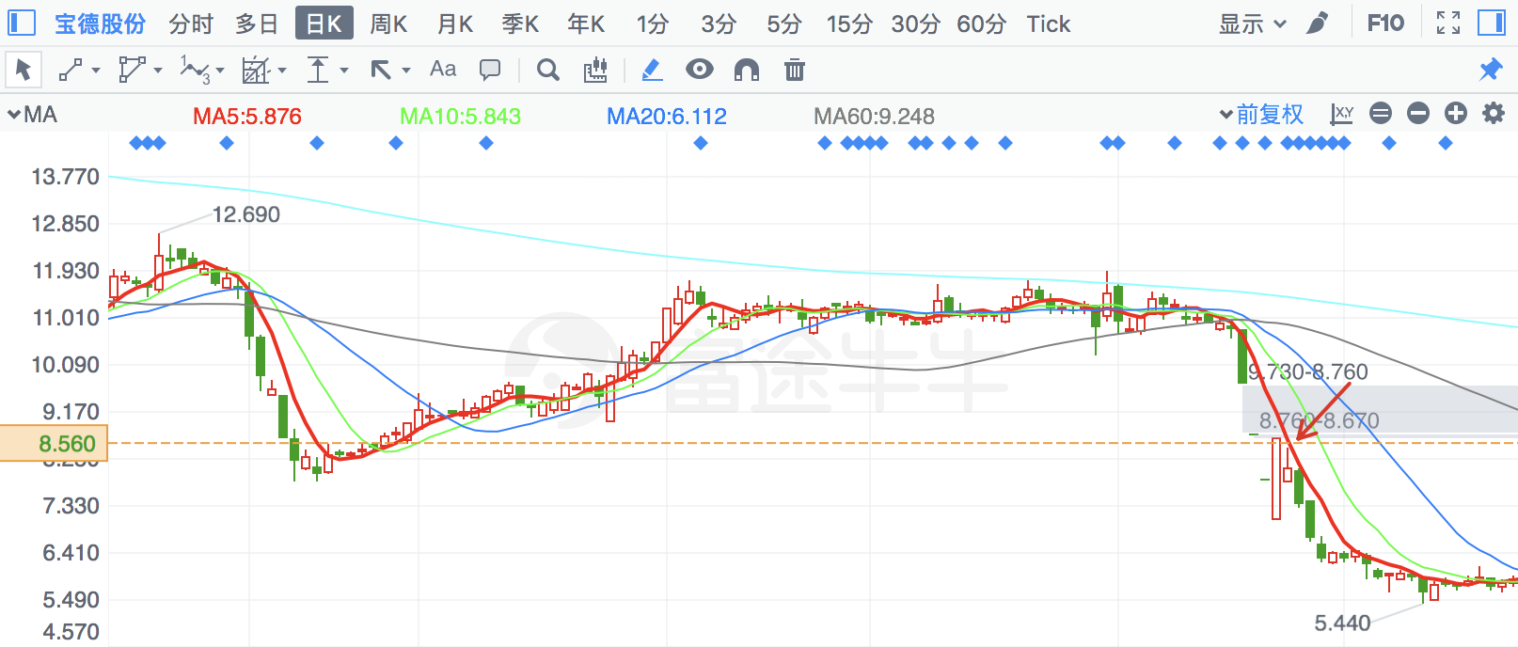

|  |  |  |
| --- | --- | --- |
| **2018/4/19** | **600929** | **湖南盐业** |

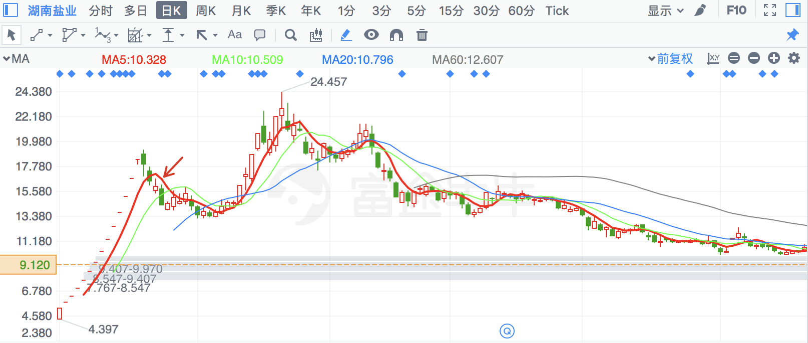

|  |  |  |
| --- | --- | --- |
| **2018/6/14** | **2684** | **猛狮科技** |

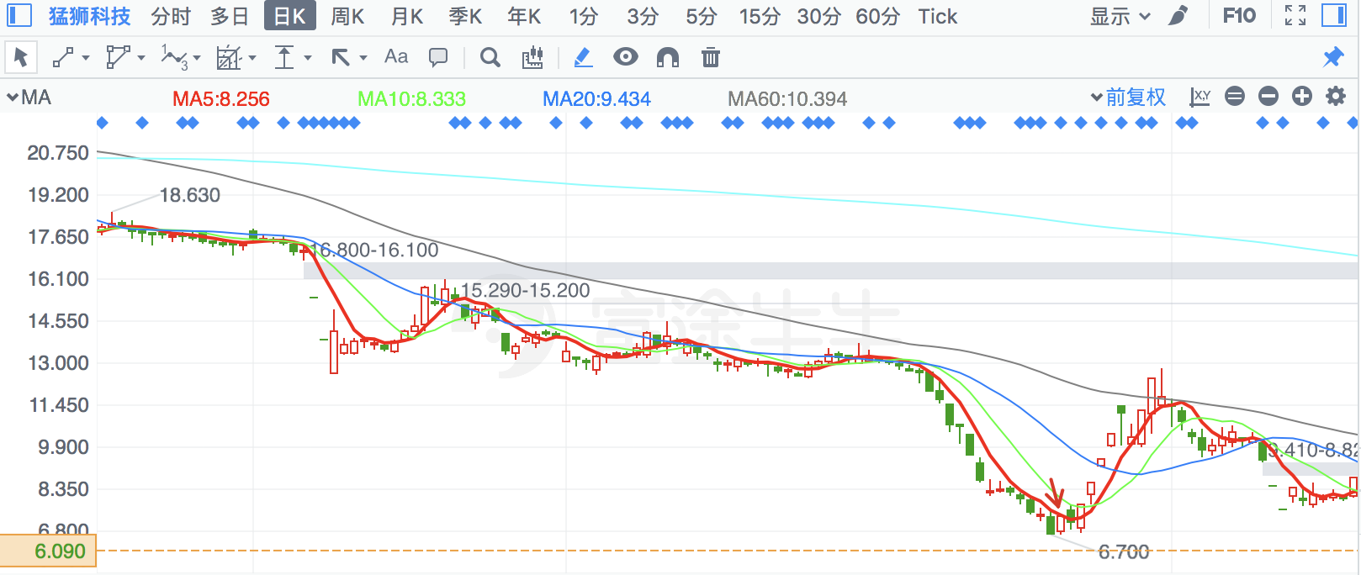

|  |  |  |
| --- | --- | --- |
| **2018/5/29** | **603655** | **朗博科技** |

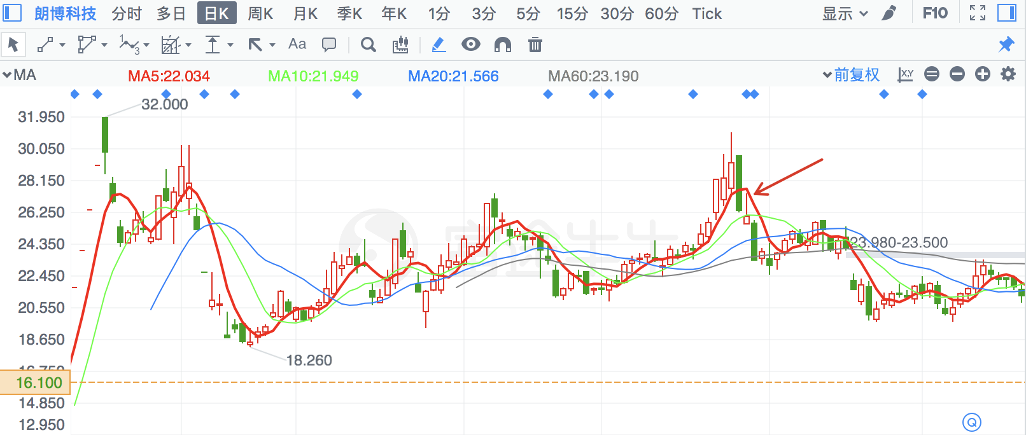

|  |  |  |
| --- | --- | --- |
| **2018/2/5** | **600468** | **百利电气** |

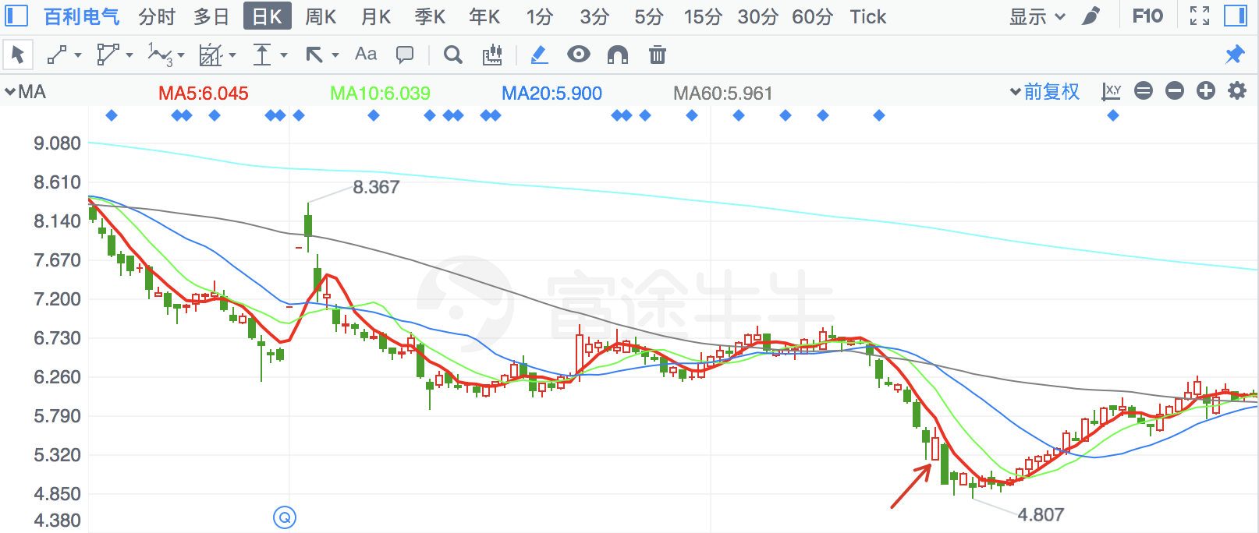

|  |  |  |
| --- | --- | --- |
| **2018/7/3** | **300731** | **科创新源** |

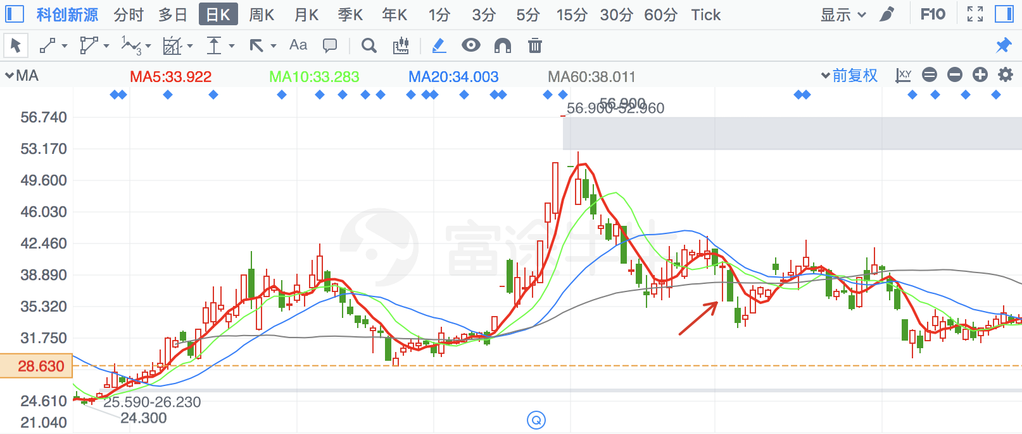

|  |  |  |
| --- | --- | --- |
| **2018/4/16** | **790** | **泰合健康** |

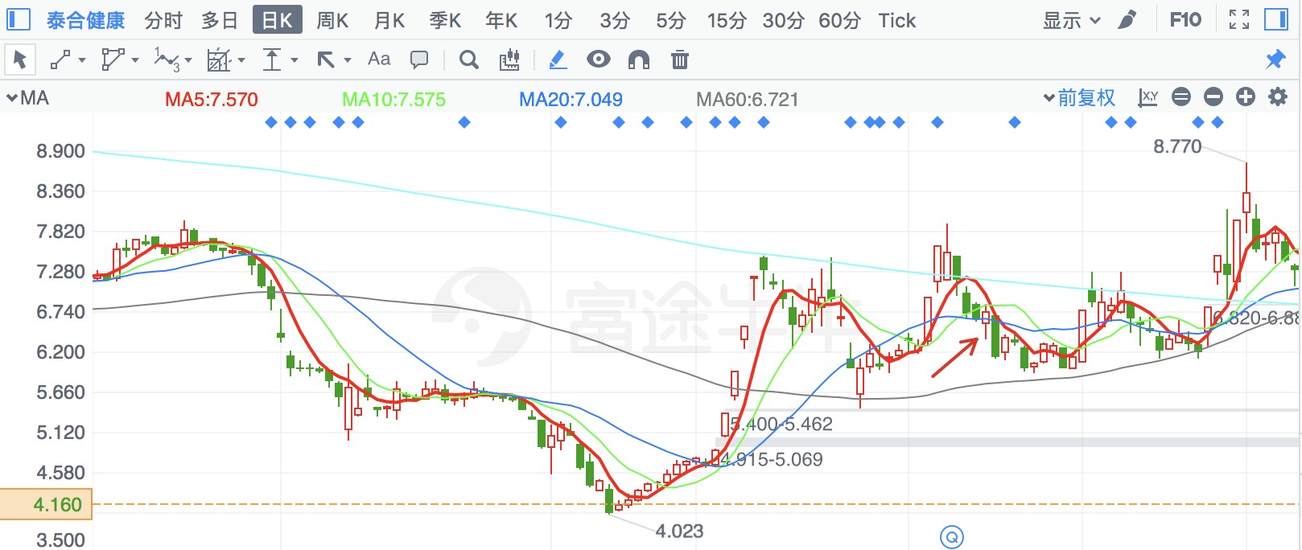

|  |  |  |
| --- | --- | --- |
| **2018/8/7** | **300720** | **海川智能** |

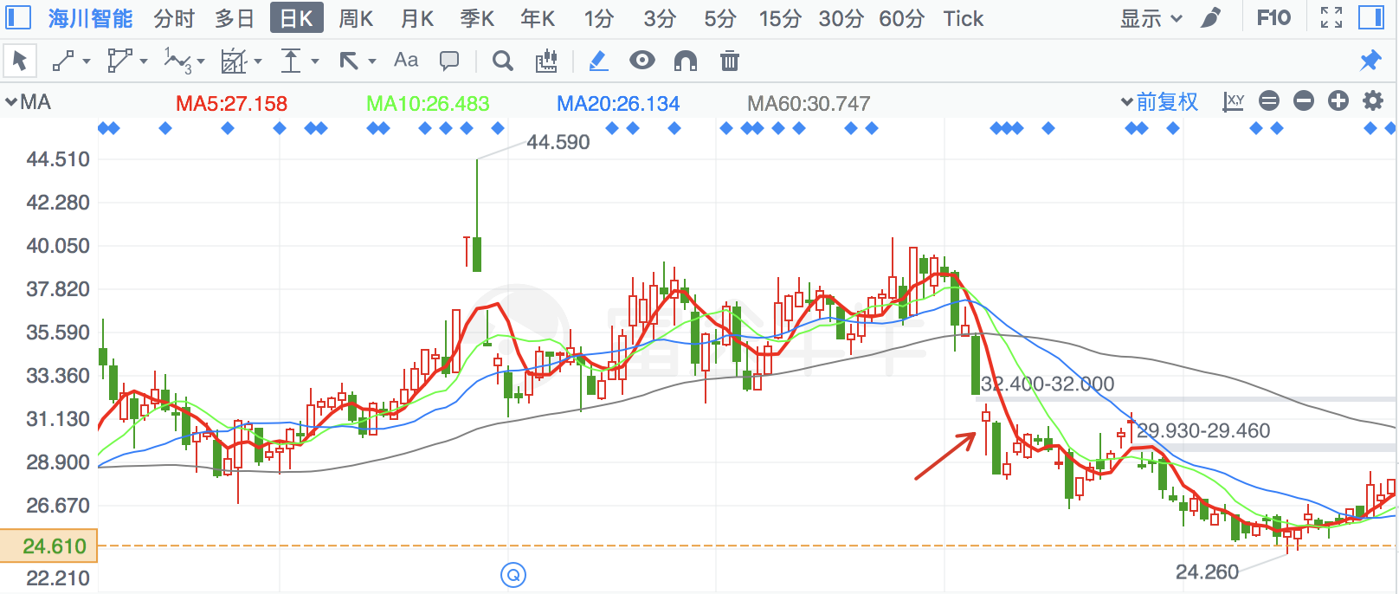

|  |  |  |
| --- | --- | --- |
| **2018/1/31** | **300618** | **寒锐钴业** |

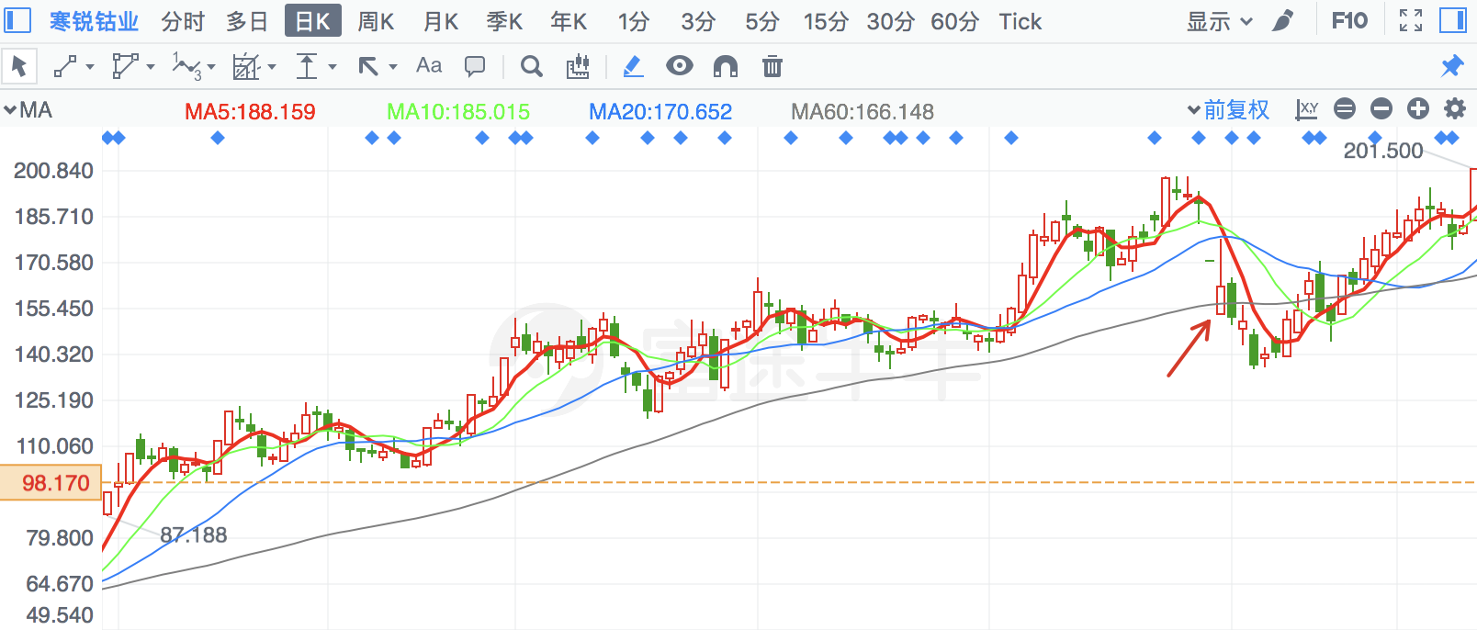

|  |  |  |
| --- | --- | --- |
| **2018/6/14** | **2696** | **百洋股份** |

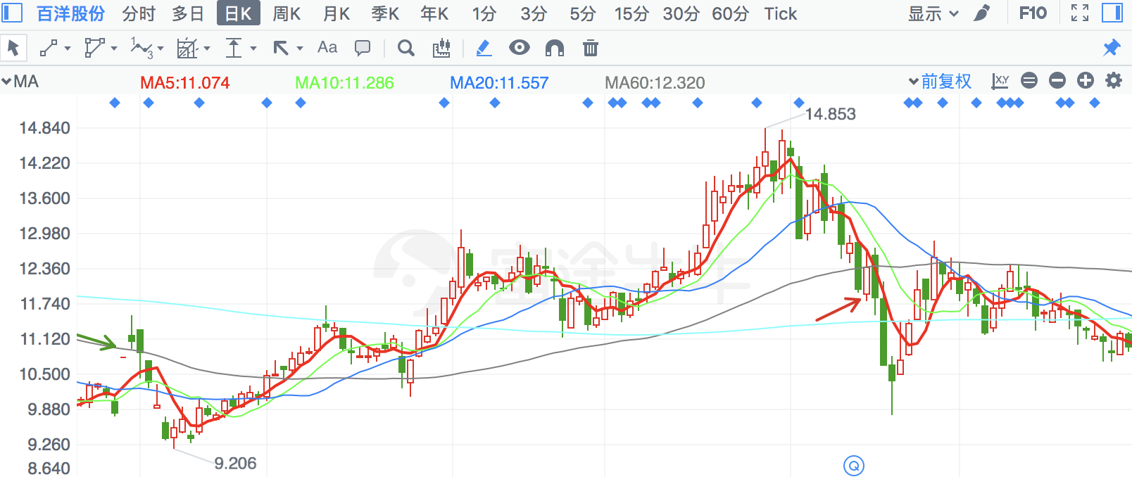

|  |  |  |
| --- | --- | --- |
| **2018/5/29** | **2198** | **嘉应制药** |

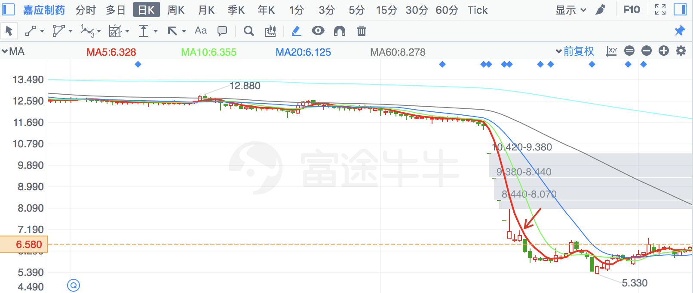

|  |  |  |
| --- | --- | --- |
| **2018/2/5** | **2264** | **新华都** |

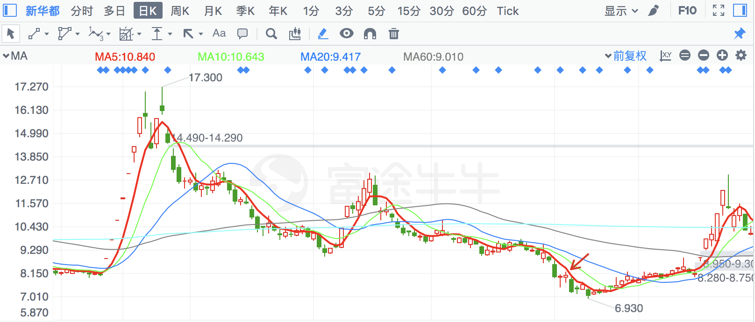

|  |  |  |
| --- | --- | --- |
| **2018/3/6** | **830** | **鲁西化工** |

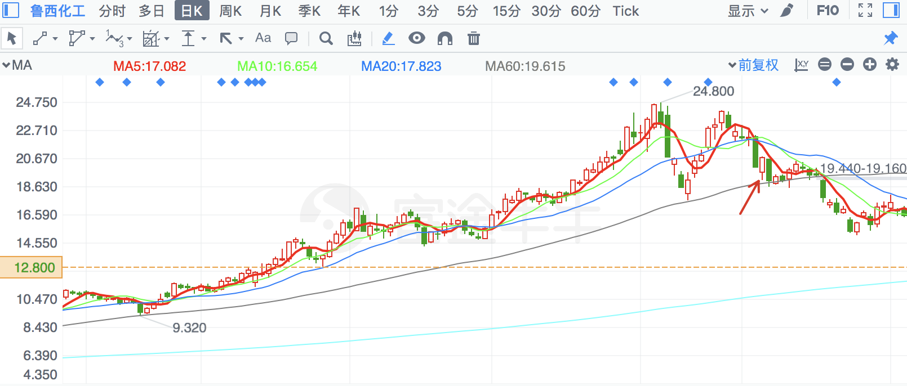

|  |  |  |
| --- | --- | --- |
| **2018/1/31** | **603988** | **中电电机** |

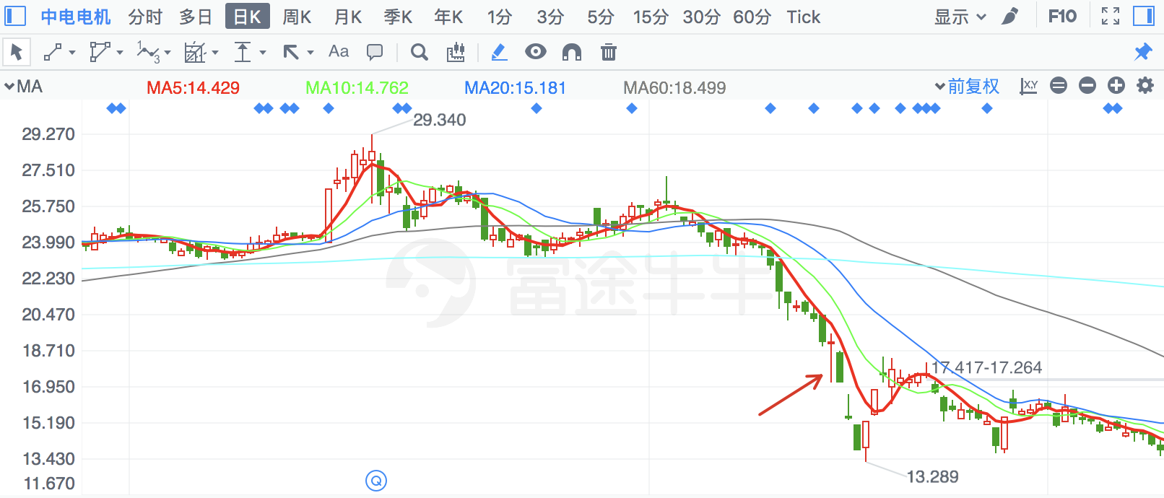

|  |  |  |
| --- | --- | --- |
| **2018/8/16** | **2901** | **大博医疗** |

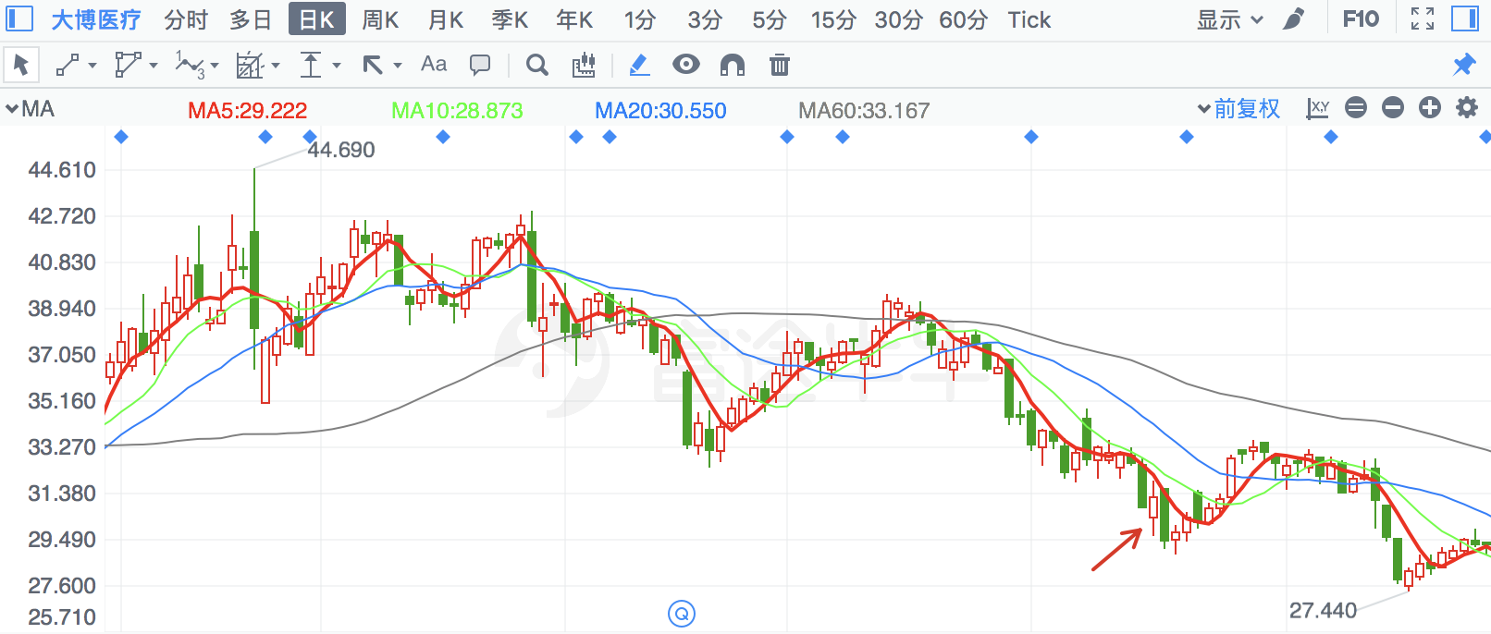

|  |  |  |
| --- | --- | --- |
| **2018/6/15** | **300068** | **南都电源** |

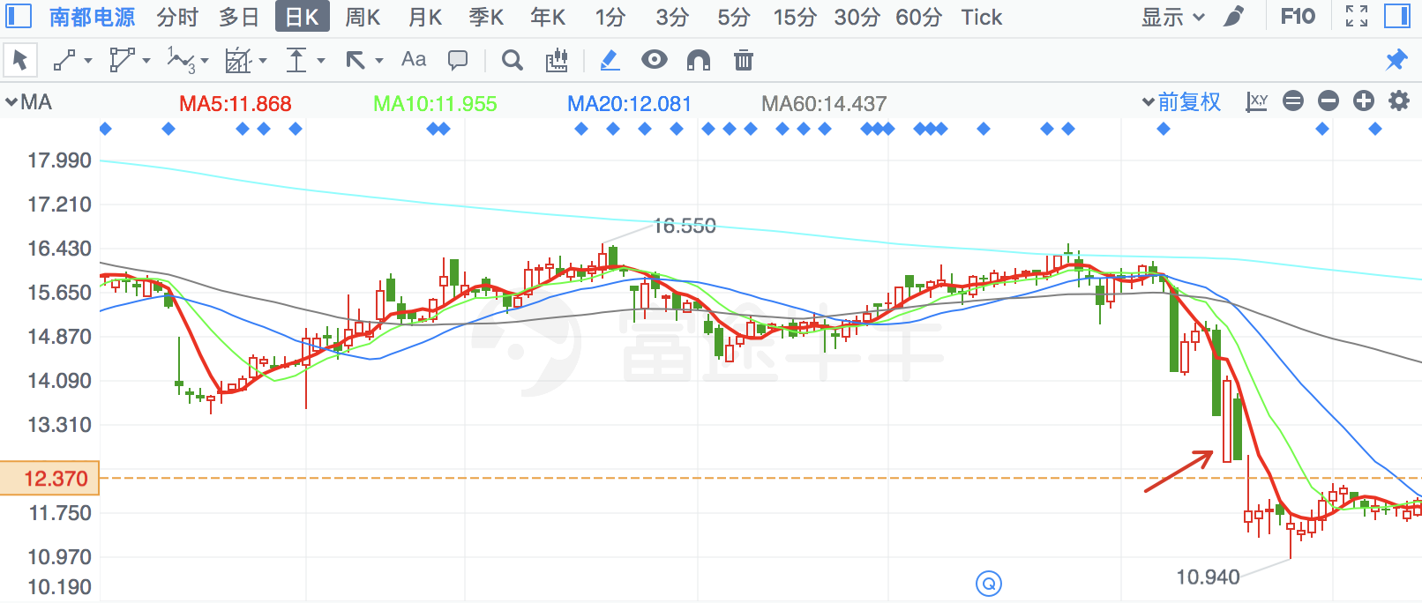

|  |  |  |
| --- | --- | --- |
| **2018/2/5** | **633** | **合金投资** |

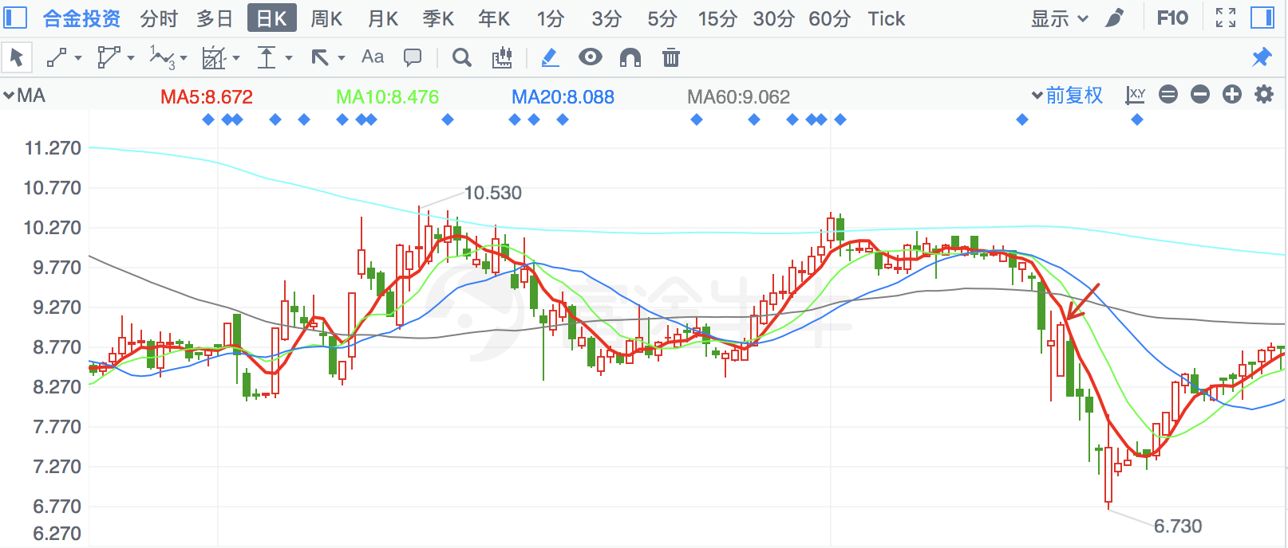

|  |  |  |
| --- | --- | --- |
| **2018/6/20** | **300682** | **朗新科技** |

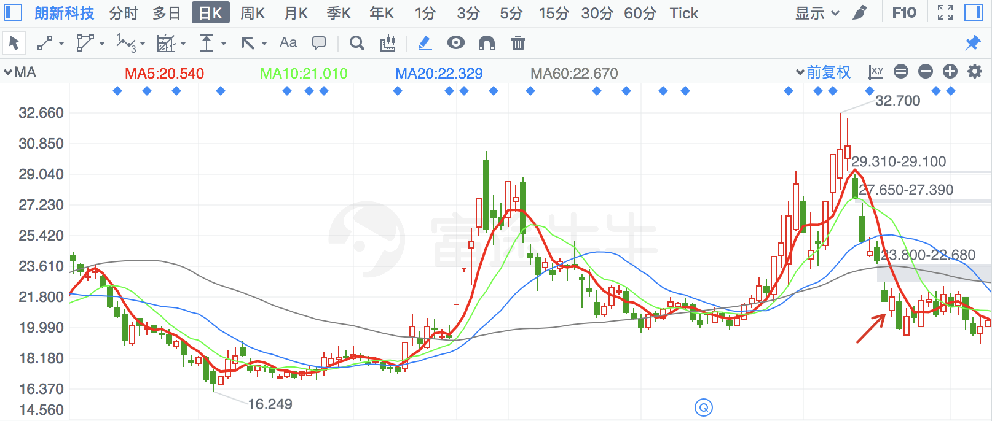

|  |  |  |
| --- | --- | --- |
| **2018/7/4** | **14** | **沙河股份** |

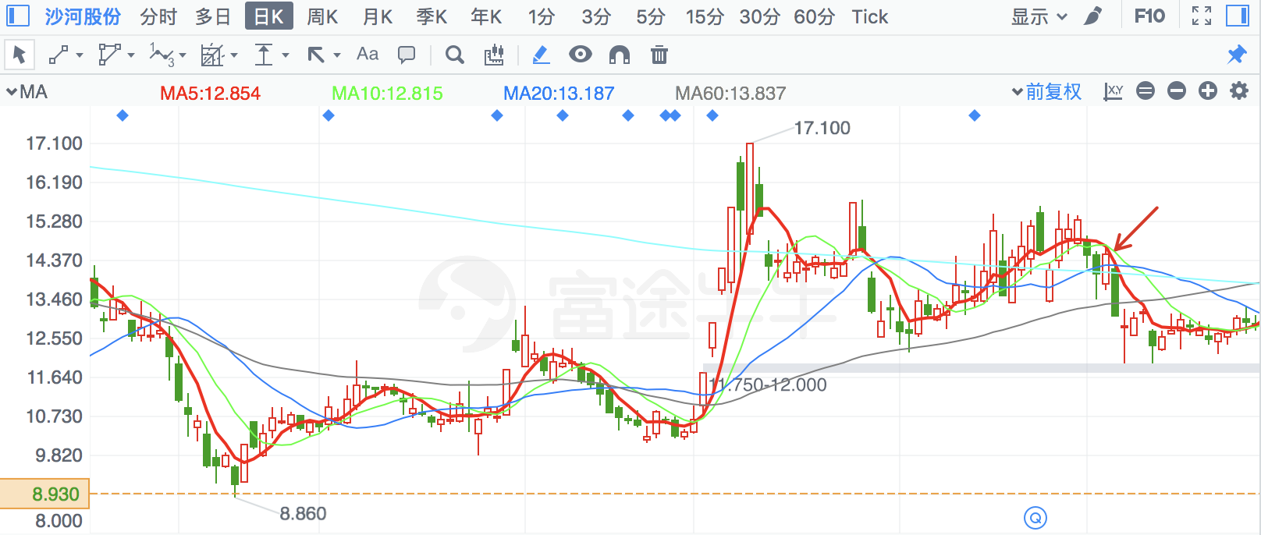

|  |  |  |
| --- | --- | --- |
| **2018/6/15** | **603486** | **科沃斯** |

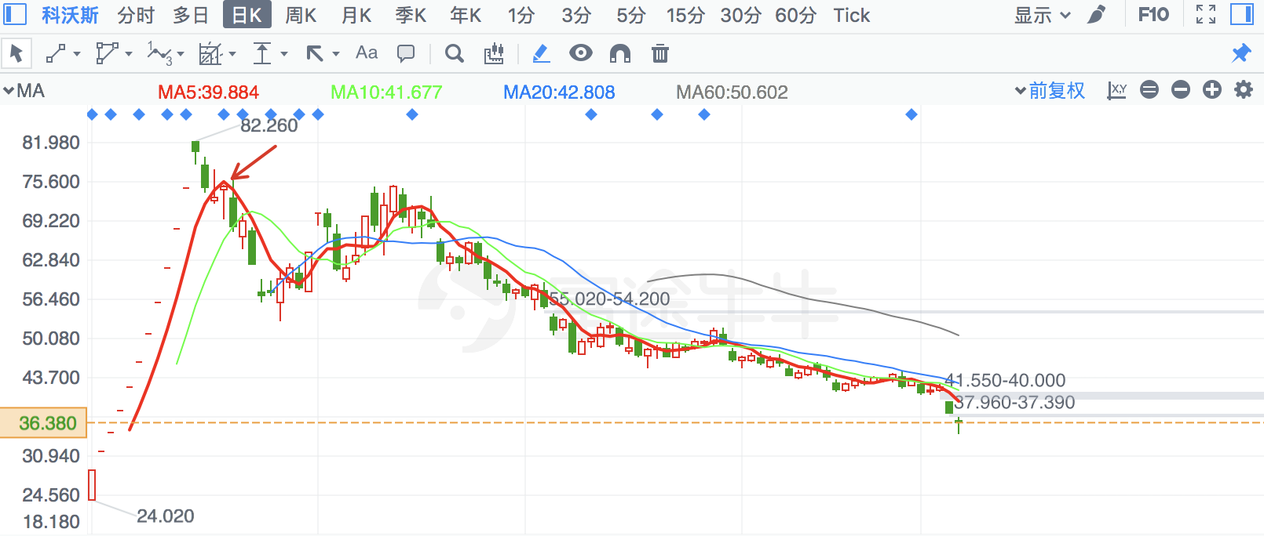

|  |  |  |
| --- | --- | --- |
| **2018/5/3** | **300634** | **彩讯股份** |

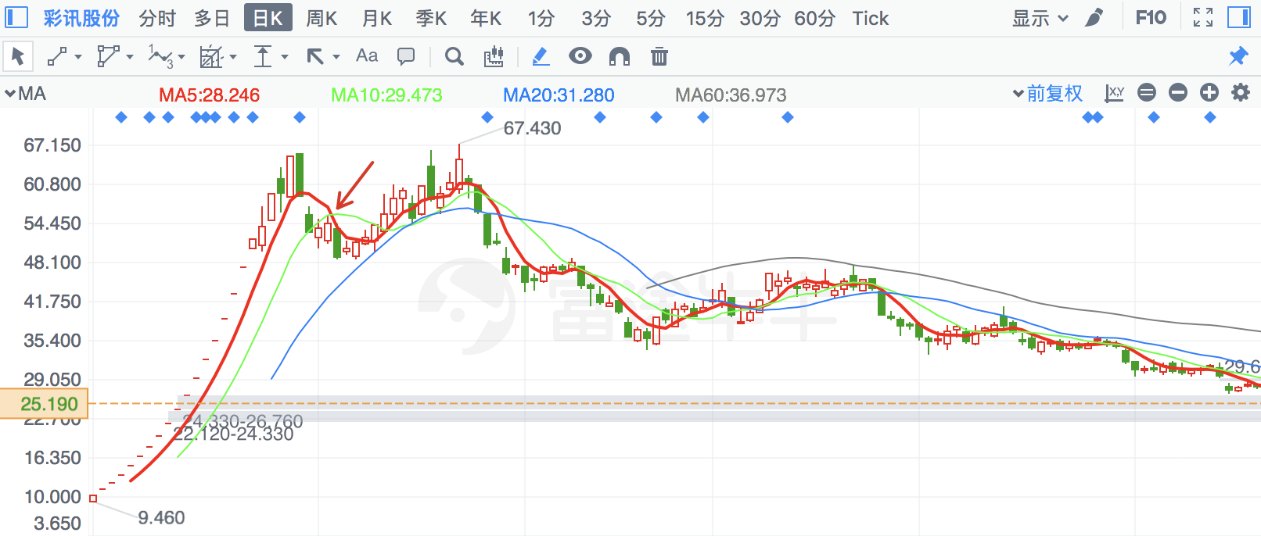

|  |  |  |
| --- | --- | --- |
| **2018/5/31** | **757** | **浩物股份** |

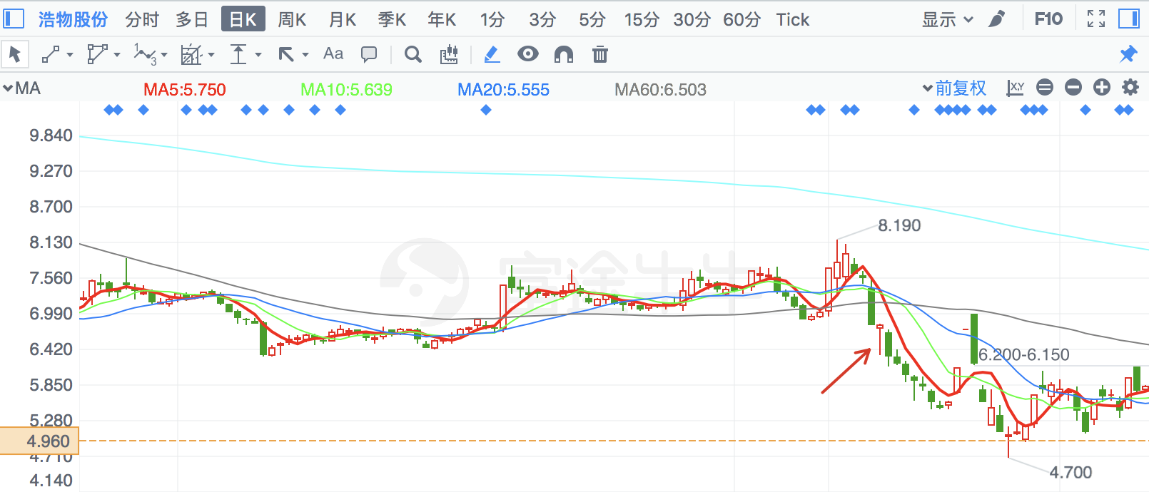

|  |  |  |
| --- | --- | --- |
| **2018/4/19** | **2320** | **海峡股份** |

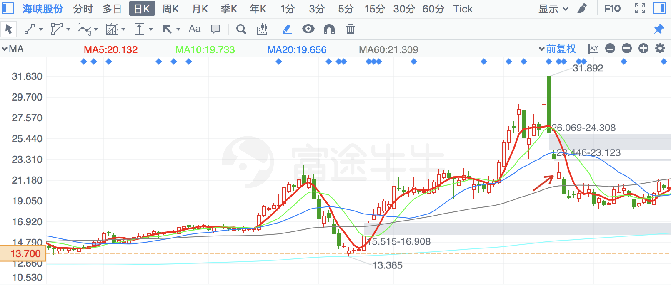

|  |  |  |
| --- | --- | --- |
| **2018/2/12** | **601838** | **成都银行** |

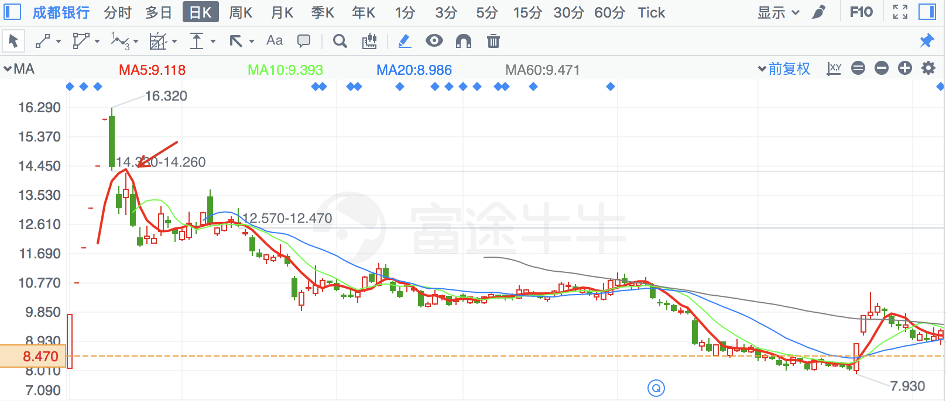

|  |  |  |
| --- | --- | --- |
| **2018/5/31** | **2103** | **广博股份** |

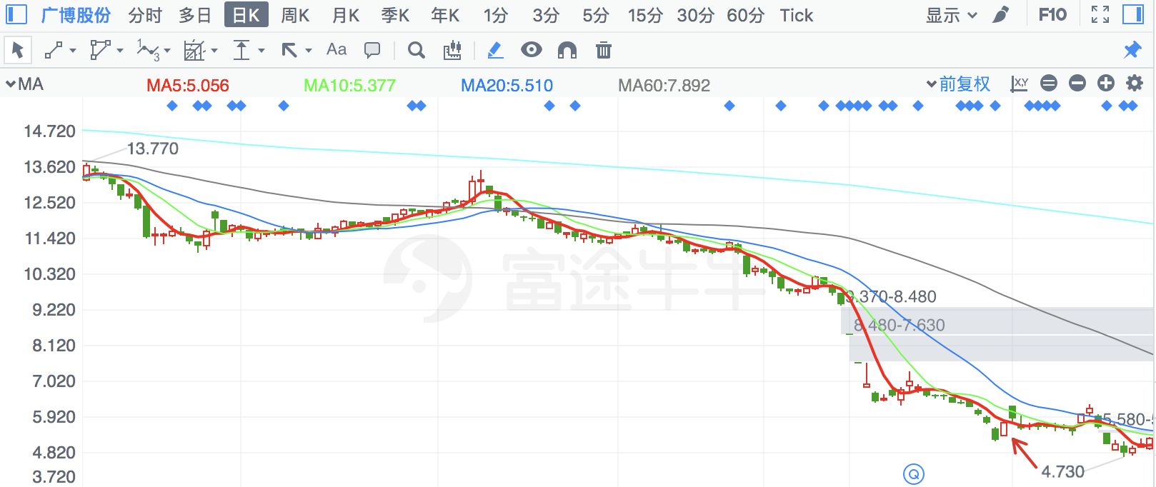

|  |  |  |
| --- | --- | --- |
| **2018/6/14** | **2356** | **赫美集团** |

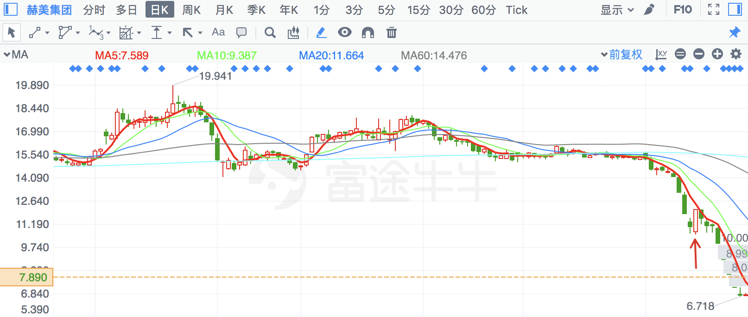

|  |  |  |
| --- | --- | --- |
| **2018/2/2** | **300065** | **海兰信** |

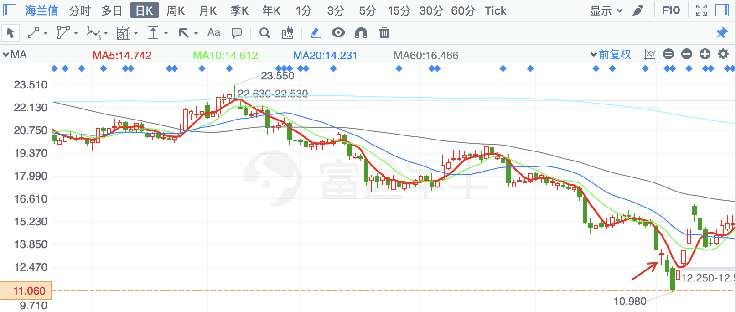

|  |  |  |
| --- | --- | --- |
| **2018/3/23** | **996** | **中国中期** |

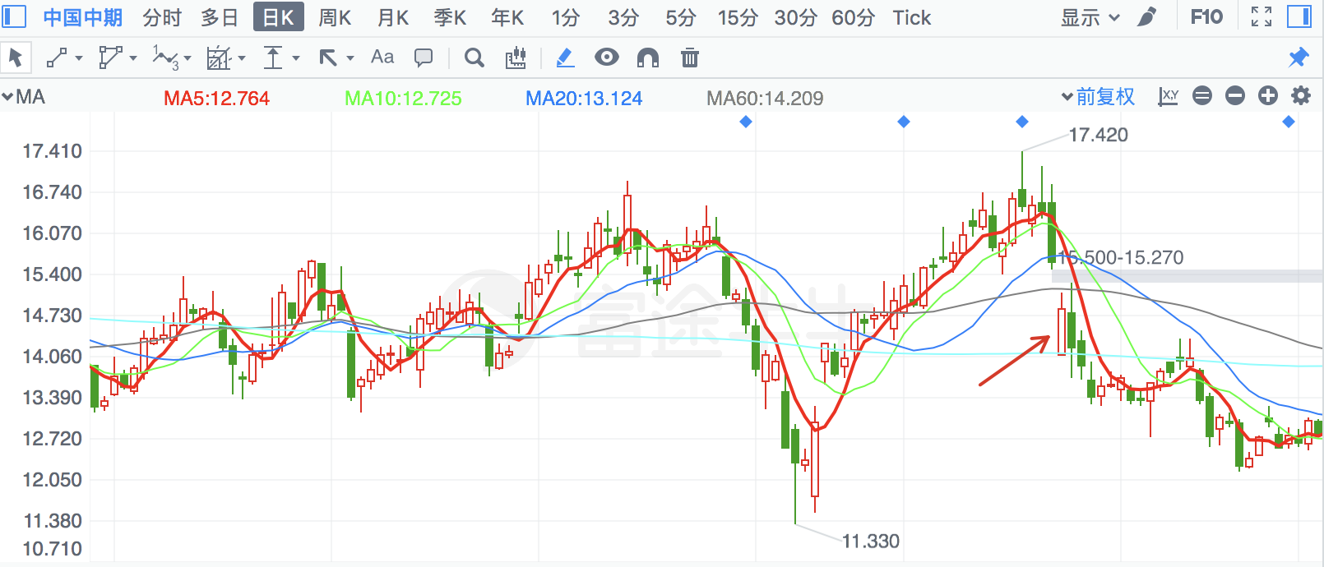

|  |  |  |
| --- | --- | --- |
| **2018/8/1** | **2932** | **明德生物** |

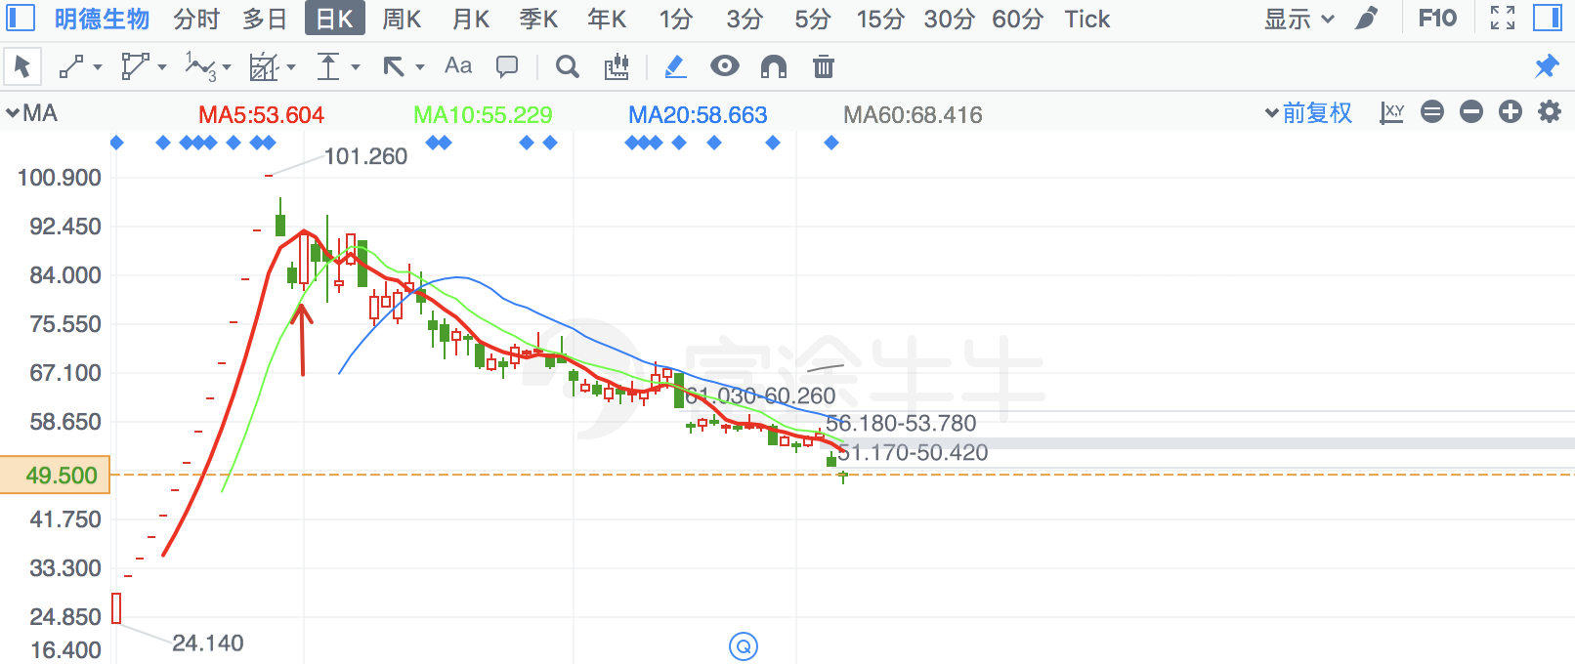

|  |  |  |
| --- | --- | --- |
| **2018/8/7** | **603986** | **兆易创新** |

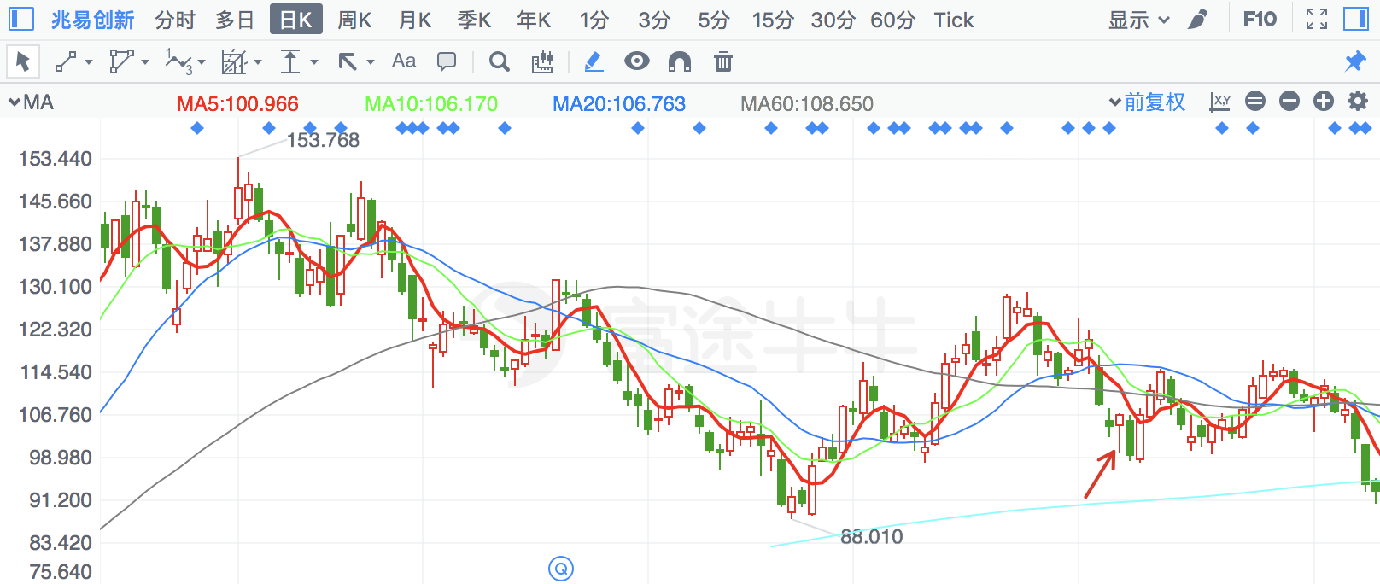

|  |  |  |
| --- | --- | --- |
| 2018/2/12 | 603058 | 永吉股份 |

